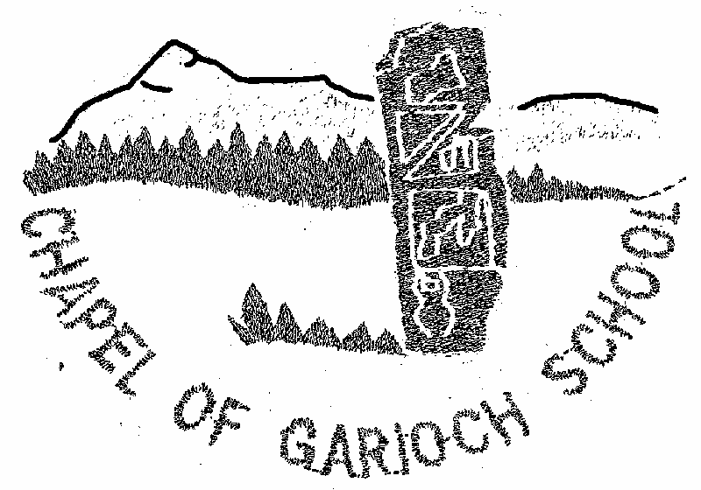

**Parent Council Meeting**

Minutes from meeting held on Thursday 18th April 2024

**ATTENDANCE**

Present:

Jen Mcwilliam (JMW), Kelly Paterson (KP), Nicola McDonald (NM), Hayley Sutherland (HS), Gemma Insley (GI), Jacqui Graham (JG), Amanda Reid (AR), Rachel Milne (RM)

Apologies:

Rebecca Pirie (RP), Catherine Paterson (CP)

**MINUTES**

1. Welcome

**JMW** welcomed everyone to the school.

2. Minutes of last Meeting and Matters Arising

The Minutes of the last meeting were approved.

3 Treasures report

The quiz we held raised over £500.

Got £75 from Easy Fundraising

We should receive a minimum of £100 from Pounds for Primaries

Looking to see if there are any Grants we can apply for.

4 HT report

No change to pupil roll or staffing since last meeting. We are expecting 5 P1s in August and the transition programme will commence once all placing requests have been confirmed across the authority on the 30th April.

Last term was a busy one for everyone, highlights included P1-3 trip to Fraserburgh lighthouse, the Parents v Pupils Challenge and Active Schools input in PE and out of school clubs. The Parent Council Quiz night was excellent, a big thanks to everyone for organising – we think it would be a popular event to keep on the calendar.

School Improvement

Learning for Sustainability

P1-3 planted an orchard on the field last term and we are really hoping the trees take, as it would be fantastic to be able to harvest some produce from those in the future and continue the learning beyond just planting.

Poly tunnel is filling up and children are getting involved on a weekly basis with all the work around this. Thank you to everyone who was on the rota for the holidays and hopefully we can keep that going over the weekends going forward.

Circle Framework

Recent pupil focus groups show that children are seeing improvement in the classroom environment particularly in the physical environment. Staff are becoming more familiar with the tool and we will continue to develop our work in this area.

Skills Ladders

Our core skills for learning, life and work developed in partnership with Inverurie Academy have been in place for a number of years and whilst they are still very relevant, we felt that in order for children and parents to understand individual development in each of these skills, a progression was necessary to outline what each skill might look like at each primary stage. We have created skills ladders and these will accompany the pupil report and will be used in order for learners to set their own targets against the skills. It would be useful for the parent council to look at these and give feedback on them before they are finalised.

Improvement Plan for 2024/25

The Circle Framework will continue to be a focus and we will also be dabbling in Play Pedagogy as well as looking at Learning, teaching and assessment in listening and talking.

5. PC Activities/ Fundraising

Spring Fair

8 people replied to google form

Asked pupil council to make video highlighting what the parent council funds

Meeting on Tuesday night at Jens’s at 7pm

6. Parent Sustainability

Rota to be carried on for the weekends – KP to create rota and send out

Rotavator – JMW to ask Travis Perkins, HS to check with GPH

7. AOB

GI spoke to the local MP in regards to the speed beside the school. Need as many parents to email the council to raise the concern.

**Please turn off your car engine off when dropping off your children & waiting for children to come out of school.**

8. Next meeting

Will be on **Thursday 27th June at 7pm at Chapel of Garioch School.**

All parents/carers welcome.