Parent Forum Meeting & Parent Council AGM

Minutes from meeting held on Thursday 12th October 2023

ATTENDANCE

Present:
Alahna Low (AL) Audrey Quaile (AQ), Nicola McDonald (NM), Jen Mcwilliam (JMW), Kelly Paterson (KP), Gemma Morrison (GM), Hayley Sutherland (HS), Catherine Paterson (CP) Jacqui Graham (JG) Amanda Reid (AR) Rachael Milne (RM)

Apologies:
Cllr Moray Grant, Rebecca Pirie

MINUTES

1. Welcome

AQ welcomed everyone to the Chapel of Garioch Parent Forum meeting and Parent Council AGM.

2. Introduction to Parent Forum

ALL parents are part of the Forum.
Q&A document about The Parent Forum as well as our mission statement is included in Appendices 1a and 1b

3. Minutes of last Meeting

The minutes of the last Parent Forum meeting (22/06/2023) were approved.

4. Chair’s report

AQ gave an overview of the last years’ Parent Council activities (see Appendix 2)

5. Treasure’s report

HS presented the accounts as audited by Gill Bayman – Very kindly does them for us. (See Appendix 3).

£2281.79 in bank account

6. Head Teacher’s report

NM gave an overview of the last years’ school activities (See Appendix 4 for details).

7. Election of new members

We have received 8 notes of interest from the following parents, 0 new notes of interest
Jen Mcwilliam – Chair
Gemma Morrison – Vice Chair
Hayley Sutherland – Treasurer
Kelly Paterson – Secretary
Catherine Paterson – member
Jaqui Graham – member
Amanda Reid – member
Rachael Milne – member
Rebecca Pirie - member

As this number is lower than the maximum 10 members, all of the above people are elected into the parent council.

AQ to update the PC what’s app group to only include these members.

The new Parent Council Committee is as follows:

Chair: Jen McWilliam
Vice Chair Gemma Morrison
Treasurer: Hayley Sutherland
Secretary: Kelly Paterson
Fundraising Coord.:
Parent Members: Catherine Paterson
Jacqui Graham
Amanda Reid
Rachael Milne
Rebecca Pirie

Co-opted local member: vacant
Local Councillors: Hazel Smith
Sam Payne
Moray Grant
Head Teacher: Nicola Mcdonald

8. AOB

Xmas party/gifts Date to be confirmed.

25th November – Christmas fair school having table.

9. Next Meeting

Thursday 9th November 7pm at Chapel of Garioch School. All parents/carers welcome.
APPENDIX 1a

Roles & Remit of the Parent Forum & Parent Council

Q: What is the Parent Forum?
A: YOU ARE - All parents of children currently at the school are automatically members of the parent forum.
Q: What is the Parent Council
A: The Parent Council is an elected group of up to 10 members of the Parent Forum, up to 4 co-opted members, the Head Teacher and the local Councillor.
Q: What are the objectives of the Chapel of Garioch Parent Council
- To represent and protect the best interests of C of G school children in their education and social development.
- To work with, and support, the school staff in representing, protecting and developing the principles by which the school is managed.
- To support the provision of appropriate school facilities, infrastructure, grounds and transport facilities.
- To work in partnership with the school to create a welcoming school that is inclusive for all parents.
- To promote partnership between the school, its pupils, all its parents and the local community.
- To develop and engage in activities which support the education and welfare of the pupils.
- To identify and represent the views of parents on the education provided by the school and other matters affecting the education and welfare of the pupils to the Head Teacher and the Local Authority.
- To establish and support any sub-groups it deems required to achieve these objectives.

Q: What does the Parent Council do?
- Represents the school at local and Scottish level (attendance at meetings).
- Supports the school development plan (e.g. in relation to Curriculum for Excellence, Eco groups etc).
- Promotes the school where ever possible.
- Assists the Head Teacher where necessary e.g. in reviewing and updating school policies.

APPENDIX 1b

Mission Statement

We, the Parent Council of Chapel of Garioch Primary School exist to fulfil the following aims:
To work closely with the Head Teacher, and teaching staff to ensure that the school runs in a smooth and disciplined manner and that all children have both the educational and personal development that they need to succeed in their futures.
To keep parents informed about school activities and issues and to act as a forum for parents' concerns and wishes for the future of the school.
To assist the school's ability to deliver a high quality educational and life experience by the raising of funds through events and organising of extra-curricular activities with the approval of the school and local authority.
To work within the wider local community to foster good relationships and a positive image between the school, the pupils, parents and the public.
The ultimate aim is to enhance both the educational and personal development of all our children in a fully inclusive and safe and happy environment.

APPENDIX 2

Chair’s Report 2022 2023

Welcome everyone to our Parent Council AGM. It’s strange to be back now that Imogen is at the Academy, but lovely to reflect on what has been an eventful last year at Chapel of Garioch School. I think its safe to say that Ms McDonald is fully settled back in, she achieved her goal of making us cry at the COGSA’s! We also welcomed Mr Small to cover for Miss Smith while she enjoys time with baby Douglas and Mrs Duncan took over the task of School Administrator. We also said goodbye to Nancy, I’m sure she’s not missing the glitter from craft club!

Supporting the School & Purchases

The Parent Council, as it always has, works hard to support the school in any way it can. Although the majority of our support is financial, we also work with the school to assess School Improvement Plans and evaluate the Schools Visions, Values and Aims to ensure they remain a good fit. This happens at our Parent Council meetings and is a good opportunity for open discussion from both sides of the school community. We encourage all parents to try and attend meetings so they can be aware of the issues being discussed and contribute their views, contributing to a full school picture.

As a small school we work hard to make sure we can offer our children every opportunity to grow and develop through learning. This was evidenced by our two biggest purchases of the year, the instillation of the new play equipment in the grounds that we had committed to fund from the previous year, and the purchase of the 5-year licence for Accelerated Reader. Looking at the weekly achievement’s photos on Facebook, there are many Ready Reader Awards being handed out!

Over the last year we were also able to support the school by funding the trip to see Santa at Alford and the school Christmas Tree, the parts needed to keep our Green Goblin Car on the road, and a £100 per child contribution towards our P7s trip to Newtonmore. The skills the P7s developed through both Green Goblin and Newtonmore will stand to them for the future. As always there were also various bus trips that we covered in full, and the ice cream treats at sports day and on the last day.

PC Meetings

In general we hold 5 Parent Council meetings per year, 1 per term plus the AGM. They have now been able to return to the school. In the past we tried to rotate them between day time and evening meetings, and this will continue if the committee feels it is appropriate.

Fundraising

Our fundraising committee worked hard, starting the year with a delicious Soup and Sweet, followed by a Craft club for the Christmas Fair and finally a very successful Spring Fair. Thank you to all parents who helped out at all our events.

As always, we welcome fundraising ideas from the whole Parent Forum and they can be sent to the generic parent council email address, cogparentcouncil@gmail.com, to be passed onto the fundraising team.

Parent Council Funds

2022 AGM – Bank Balance c£6.7K

2023 AGM – Bank Balance c£2.2K

New Parent Council

Our new constitution came into effect from the 2018 AGM. This changed the way members are voted onto the council. An email was sent out last month asking for nominations. As the number received does not exceed 10 we do not need to implement the Parent Forum voting, and all nominees are automatically voted onto the council.

We have notes of interest from the following for this year:

Jennifer McWilliam – Chair

Gemma Morrison – Vice Chair

Hayley Sutherland - Treasurer

Kelly Paterson - Secretary

Jacqueline Graham

Catherine Paterson

Amanda Reid

Rebecca Pirie

The position of Chair remains vacant, unless there are any last minute volunteers to fill the position.

I am delighted that we have some new members on the parent council, representing both classes at the school.

All parents and carers with children at the school are part of the parent forum, and as such can attend all meetings. However, we need new parents to join the parent council so ensure the continuity needed to fully support the school going forward.

Many thanks to outgoing committee member Alahna and Denise for their many years of support for the committee and the school and we wish them and all the best for the future.

Year Ahead

This is a hard paragraph for me to write as I will no longer be involved in the planning and organising of events and activities at the school, of which I am sure there will be plenty! However I look forward to coming along and enjoying fundraisers without the hard work! With the ongoing dedication of the new Parent Council and Fundraising Committee, Chapel of Garioch School and its community will continue to prosper. Its great to see new committee members who can bring fresh views and ideas, and I wish everyone every success for the year ahead.

Thank you

Audrey Quaile

Parent Council Chair

2022/23

APPENDIX 3

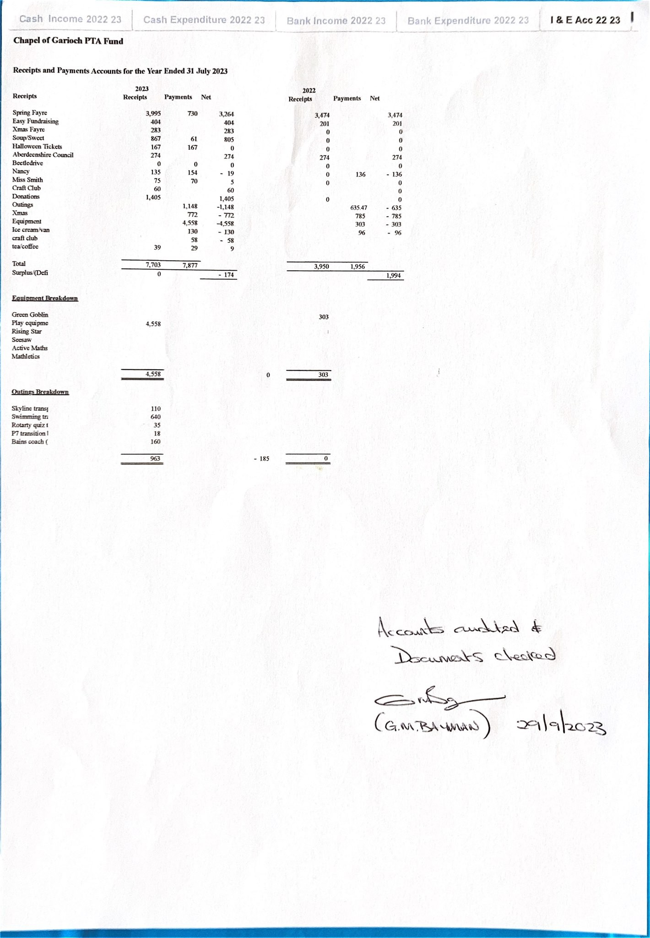
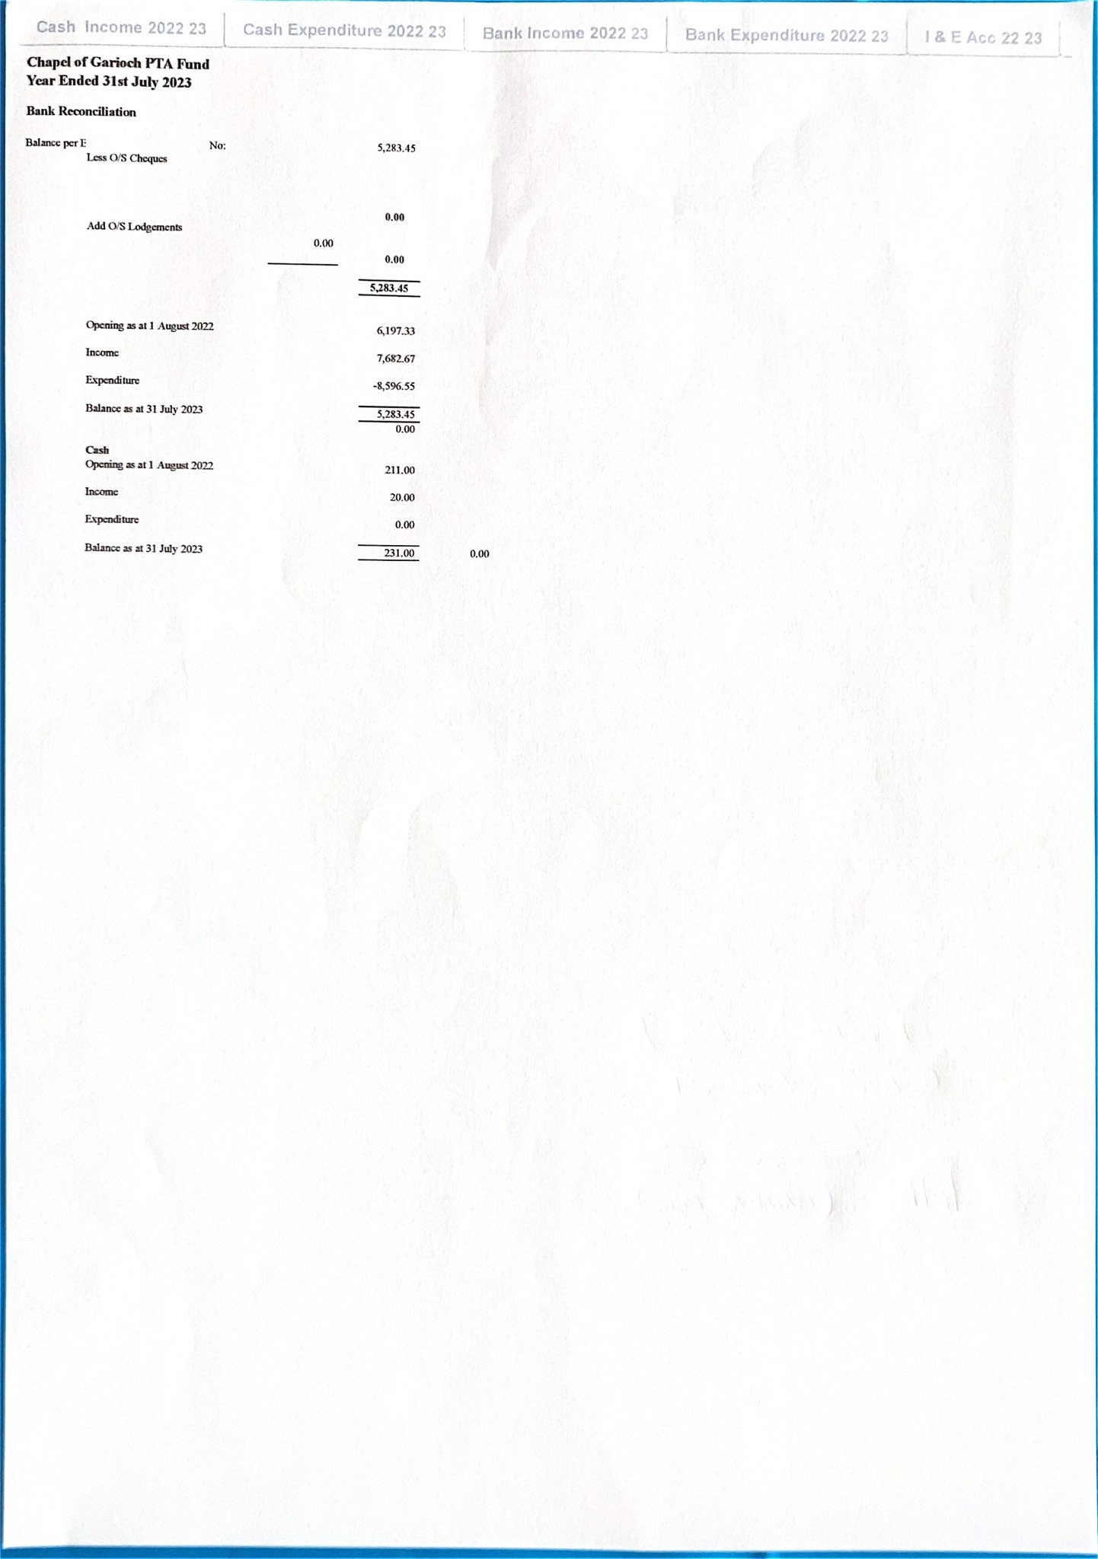

APPENDIX 4
School Roll: 29
Staffing: Stable at present but changes will come later in the year upon the return of Miss Smith from Maternity leave. PSA hours are not confirmed as yet, but we expect to know this early November.
Standards and Quality Report
The standards and quality report for last session is published on the website.
School Improvement Plan 2023/24
The plan can be read in full on the school website, along with an overview of the two main priorities, however some of the key activities include:
The Circle Framework – an authority wide approach to inclusive learning and collaborative learning.
· The learning environment - through consultation with pupils and staff we will seek to ensure our classrooms and other learning environments both physical and social, fully support all learners to participate and engage in learning with no barriers.
· Structures and Routines – through pupil feedback, we will review all structures and routines in school to ensure that they support all learners.
· Motivation – through observation, pupil focus groups and questionnaires, we will look at the motivation of our learners in terms of enthusiasm and interest when engaging in activities. We will identify what motivates our learners so that we can use this information to plan our experiences to ensure a high level of motivation and therefor high engagement and participation leading to positive outcomes.
Learning for Sustainability – a continuation of the great work done last year. The plan can be read in full on the school website, along with an overview, however some of the key activities include;
· A new STEM progression for the school which will be based upon sustainability.
· 2 new projects based around carbon capture and renewables.
· Polytunnel Project with established parent sustainability group.
· Careers Education programme related to careers in renewables and other Green industries.
The school is part of a Validated Self Evaluation Trio and we had our first visit which focussed on our improvement plan which received very positive feedback.
Good progress has been made this term already in both the above plans including staff development days and planning.
SPCA Visit took place on the 25th of September which was based around biodiversity which links into Learning for Sustainability.
We had a visit from Kizzy Scott from the British Ski team, who worked with the P4-7 class during Women and Girls in sport week.
Coming Up…
Logo Launch
Christmas Activities still to be decided
Technology funding

