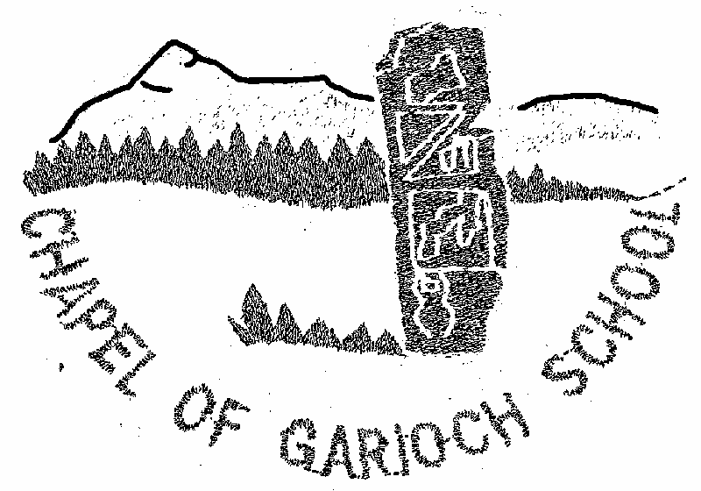

Parent Council Meeting

Minutes from meeting held on Thursday 22nd June 2023

ATTENDANCE

Present:
Alahna Low (AL) Audrey Quaile (AQ), Nicola McDonald (NM), Kelly Paterson (KP), Hayley Sutherland (HS), Denise Holway (DH), Amanda Reid (AR) Gemma Insley (GI) Sarah Sunley (SS) Jennifer Murray (JM)

Apologies:
Jen Mcwilliam (JMW), Rachael Milne (RM),

MINUTES

1. Welcome

AQ welcomed everyone to the school.

2. Minutes of last Meeting and Matters Arising

The Minutes of the last meeting were approved.

3 Treasures report

Balance as at today is £6300.95

Spring Fair - Around £3200 raised

Easy funding - £300 raised

4 HT report

School roll will be 29 as of August 2023. Staffing likely to be the same as it is currently with the exception of PSA hours. We have paid for additional hours this session from our Pupil Equity Funding and Covid Recovery Funding. We no longer have the latter and the former is significantly less this session. We are allocated 17 hours from the cluster, and we will look at what we can afford from the PEF to see if we can manage any additional hours this coming session.

Standards and Quality Report/School Improvement Plan 2022/23

Learning for Sustainability

· New Polytunnel in process

· Successful Completion of John Muir award.

· New sustainability award for pupil at COGSAs

To improve the assessment of writing across the school.

· New writing progressions in place

· Moderation activities attended with cluster

· Staff refresher training in BIG writing

Supporting learners’ needs & removing barriers to learning. (Inverurie Cluster)

Created a working group for embarking on CIRCLE framework within cluster.

Green Goblin

We had an excellent day at Alford for the Greenpower event winning the best bodywork award. Pupils got so much out of this project using and further developing many skills. It was by far the best year we have had and that was mainly down to our BP student Maria. Next year, we will take a break from the project with a view to having the P6s and 7s work on it together again in session 2024/25.

Transition

The transition program has gone well this year, P7s enjoyed their days at the Academy and have now got the residential trip to look forward to. P1s have been in and visited their class and have been making use of the transition bags. P3s have spent some time in the P4-7 class as well, which seems to have gone well.

Looking ahead to next session, the improvement plan is likely to continue to focus on the same themes as we would like to continue to really embed what we have done this session. We will be putting out a parent questionnaire next week which will feed into the Standards and Quality Report.

5. PC Activities/ Fundraising

We are open to any suggestion on fundraising ideas please feel free to contact any member of the parent council forum or email your ideas to (cogparentcouncil@gmail.com)

6. AOB

New banner for school fair,

Banner for the school

Going to plan dates for all school fundraising events so people can know in advanced when events will take place.

7. Next meeting & AGM

Will be on Thursday 12th October at 7.30pm at Chapel of Garioch School.

All parents/carers welcome.

