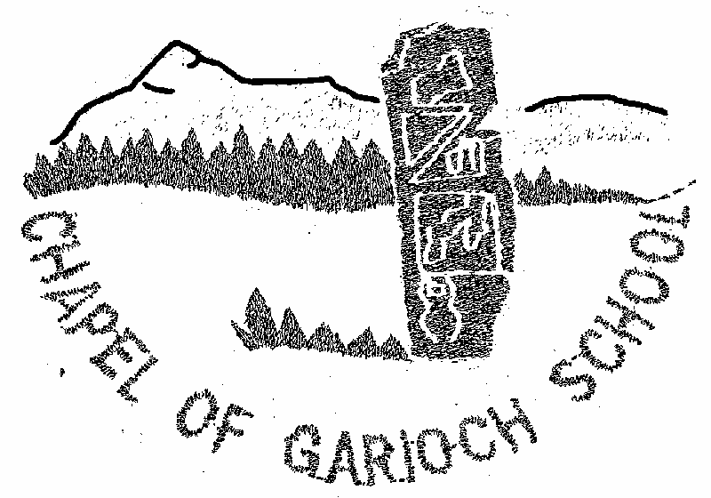

Parent Council Meeting

Minutes from meeting held on Thursday 27th April 2023

ATTENDANCE

Present:
Alahna Low (AL) Audrey Quaile (AQ), Nicola McDonald (NM), Jen Mcwilliam (JMW), Kelly Paterson (KP), Hayley Sutherland (HS), Denise Holway (DH), Sarah Sunley (SS), Rebecca Pirie (RP), Amanda Reid (AR), Rachael Milne (RM)

Apologies:
Gemma Insley (GI) Cllr Hazel Smith (HS)

MINUTES

1. Welcome

AQ welcomed everyone to the school.

2. Minutes of last Meeting and Matters Arising

The Minutes of the last meeting were approved.

3 Treasures report

Balance as at today is £2717.92

£500 from Tesco

£700 – P7 trip to Newtonmore

4 HT report

Standards and Quality Report/School Improvement Plan
Learning for Sustainability
· New Polytunnel delivered, ready to be erected with help from Mr Stewart
· John Muir award planned and our first visit to Bennachie is on the 16th May.
To improve the assessment of writing across the school.
· Moderation of writing for second level to take place with the faculty of English in May
· For First Level, we will work with other First Level teachers from across the cluster.
Supporting learners’ needs & removing barriers to learning. (Inverurie Cluster)
· Work being done with the small schools in the cluster to look at The Circle Framework with a view to this being on our improvement plan for 2023/24. In short this is about making classrooms more inclusive and creating the best learning environment that meets that needs of all learners. The three focus areas are The Physical Environment, The Social Environment and Structures and Routines. We will be undertaking thorough self-evaluation around these areas in preparation for writing our school improvement plan for next session.
Social Media
Mrs Duncan has been working with our Love Learning Digital Technology team to upskill herself on using the school website, so you will begin to see that becoming up to date. In August, we will look to populate it more with Parent Council details etc.
Play Equipment
This is being enjoyed everyday, although the weather isn’t being as kind as we would like at the minute.
Self-Evaluation Activity Parent Council – 27/04/23
Do you feel that children have a good relationship with staff at Chapel of Garioch School? How do you know?
Responses: Yes
· Talk about staff positively.
· Strong bonds
· Teachers rotation gains familiarity/security
· Long serving teachers gives feeling of “family”
· keen to go to school/happy
Do you feel that children have good relationships with each other? How do you know?
Responses: Yes
· talk about friends.
· inclusive
· caring

Does your child feel valued and secure at school? How do you know?
Reponses: YES
· awards – drives positivity and encouragement. (can also be a negativity)
· timing of awards unclear
Do you feel that school communicates well with you as parents about your child’s development, behaviour and wellbeing in school?
Responses: Yes
· Issues dealt with in a timely manner (good/bad)
· Open door
· Workshops – positive
· Parents feel they can contact with anything.

5. PC Activities/ Fundraising

Beetle drive to be held August date to be confirmed.
We are open to any suggestion on fundraising ideas please feel free to contact any member of the parent council forum or email your ideas to (cogparentcouncil@gmail.com)

6. AOB

Please turn off your car engine off when dropping off your children & waiting for children to come out of school.

7. Next meeting

Will be on Thursday 22th June at 7.15pm at Chapel of Garioch School.

All parents/carers welcome.

